WEST MAMPRUSI MUNICIPAL ASSEMBLY
ENVIRONMENTAL HEALTH AND SANITATION UNIT
REPORT ON NATIONAL SANITATION DAY CLEAN-UP EXERCISE
1ST AUGUST, 2026
Compiled by: Municipal Environmental Health Officer | 1st August, 2026

1. ACTIVITY OVERVIEW

Background
The National Sanitation Day (NSD) initiative remains one of the Government of Ghana's flagship interventions aimed at promoting environmental cleanliness, preventing sanitation-related diseases, and fostering a culture of good environmental stewardship among citizens. The initiative provides a platform for Metropolitan, Municipal and District Assemblies (MMDAs), traditional authorities, institutions, and community members to work collaboratively towards creating cleaner, healthier, and more resilient communities.
Within the West Mamprusi Municipality, rapid population growth, increasing urban activities, indiscriminate disposal of solid waste, blocked drainage systems, and poor sanitation practices continue to pose significant environmental and public health challenges. These conditions are particularly evident during the rainy season, when choked drains contribute to flooding, create breeding grounds for disease vectors such as mosquitoes and flies, and increase the risk of sanitation-related diseases including malaria, cholera, diarrhoea, and typhoid fever. Addressing these challenges requires sustained public education, community participation, and regular sanitation interventions.
In support of the national sanitation agenda, the Environmental Health and Sanitation Unit of the West Mamprusi Municipal Assembly organised and coordinated the August 2026 National Sanitation Day exercise on Saturday, 1st August 2026, within the Walewale and other zonal Councils. The exercise formed part of the Assembly's commitment to improving environmental sanitation and ensuring compliance with national sanitation policies and local environmental health regulations.
The exercise focused on the desilting of drains, sweeping of principal streets and public spaces, weeding of overgrown areas, collection and evacuation of refuse from unauthorized dumping sites, and public education on proper waste management and environmental hygiene. These activities were undertaken to improve the aesthetic appearance of the municipality, reduce environmental pollution, minimize the occurrence of flooding during the rainy season, and promote healthier living conditions for residents.
The exercise also sought to strengthen community ownership of sanitation activities by encouraging active participation from Assembly Members, traditional authorities, security agencies, youth groups, market associations, community-based organisations, and residents. Through collaborative action and continuous public awareness, the Assembly aims to foster a positive behavioural change that will encourage proper waste disposal practices, regular environmental clean-up activities, and collective responsibility for maintaining a clean and healthy municipality.
This report presents an account of the activities undertaken during the August 2026 National Sanitation Day exercise, highlights the achievements made, identifies the challenges encountered, and provides recommendations to improve the planning and implementation of future sanitation exercises within the municipality.

Objectives
- To improve environmental sanitation within the municipality
- To reduce water borne and related diseases in this rainy season.
- To reduce indiscriminate waste disposal and drainage obstruction
- To promote positive sanitation behaviour among residents
- To strengthen public participation in communal sanitation activities
- To enhance enforcement of sanitation bye-laws and regulations
Key Partners and Volunteers
The exercise was undertaken in collaboration with Environmental Health Officers, Assembly Members, Zoomlion Ghana Limited, unit committees, and community volunteers. Media engagement played a significant role, with public sensitisation carried out through Eagle FM and other local radio platforms to enhance awareness and participation.
2. SCOPE

Areas Covered
The clean-up exercise was scheduled to all the seven Zonal Councils, covering key sanitation hotspots such as:
- Central business areas(Stores)
- Lorry terminals
- Market surroundings
- Choked drainage channels within the township

Rationale for Area Selection
The selected areas represent zones with high human activity and waste generation. These locations are often characterised by poor waste disposal practices and blocked drainage systems, making them prone to flooding and increased risk of sanitation-related diseases.

GPS Locations (selected sites)
- Diani: MW-00844-4336
- Tinguri: MW-01682-7764
- Bugyapaala: MW-00001-3585
- Kinkandina : MW-04051-2197

Photographic evidence and operational maps are provided in the Annexes.
3. PREPARATORY ACTIVITIES

Community Entry and Stakeholder Engagement
Engagements were carried out with community leaders and Assembly Members within all the seven Zonal Councils to facilitate community mobilisation and cooperation.
A one-day planning meeting was organised prior to the exercise to outline operational strategies, assign responsibilities, and coordinate logistics. Key stakeholders including Environmental Health Officers and Assembly representatives participated to ensure effective implementation.
Sensitisation and Communication
Public announcements were made through Eagle FM and other local radio stations. A radio sensitisation programme was conducted to educate residents on the importance of sanitation and to encourage active participation.
Key Findings from Reconnaissance
A reconnaissance survey was conducted by the Environmental Health and Sanitation Unit prior to the National Sanitation Day exercise to assess the sanitation situation within the operational area and identify priority locations for intervention. The assessment revealed the following:
- Accumulation of plastic, organic, and other solid waste in public spaces, open areas, and along road shoulders.
- Choked drains and gutters due to the build-up of silt, plastics, sand, and other refuse, impeding the free flow of stormwater.
- Presence of unauthorized and illegal refuse dumping sites within residential neighbourhoods and undeveloped plots.
- Poor household solid waste management practices, including indiscriminate disposal of waste into drains, open spaces, and roadsides.
- Overgrown weeds around public places, vacant plots, and drainage channels, providing breeding grounds for pests and reptiles.
- Inadequate sweeping and routine cleaning of some public spaces, contributing to litter accumulation.
- Improper storage of household waste, with some residents using uncovered containers that attract flies and rodents.
- Evidence of open burning of solid waste in some locations, contributing to environmental pollution and poor air quality.
- Stagnant water in blocked drains and low-lying areas, creating favourable breeding sites for mosquitoes and increasing the risk of vector-borne diseases.
- Low public compliance with environmental sanitation by-laws, particularly regarding indiscriminate littering and waste disposal.
- Limited availability and use of waste receptacles at strategic public locations, resulting in littering.
- Public awareness of the importance of environmental sanitation remains inadequate in some communities, indicating the need for intensified education and behaviour change communication.

Logistics Mobilisation
Refuse collection trucks, wheelbarrows, sanitation tools, and personal protective equipment (PPE) were mobilised and strategically distributed across operational zones to support the exercise.

4. IMPLEMENTATION OF NSD CLEAN-UP ACTIVITIES

Date: 1th August, 2026 | Time: 8:00 AM – 12:00 pm

Activities Carried Out
- General sweeping of streets and public spaces
- Collection and evacuation of solid waste
- Desilting of choked gutters and drainage systems
- Clearing of unauthorised dumpsites
- Environmental sanitation within market and lorry station areas

Number of Participants
Over hundreds of participants took part including Assembly workers, community members, security personnel, Zoomlion Ghana Limited staff, Assembly Members, National Service Personnel, and attachment students.
Logistics and Equipment Used
Refuse skip truck, wheelbarrows, shovels, rakes, pickaxes, brooms, and sanitation implements. PPE including hand gloves and nose masks were provided to ensure occupational safety.
Operational Challenges on the Day
- Inadequate sanitation tools relative to the number of volunteers
- Low participation in some residential areas
- Negative attitudes of some residents towards communal labour

5. OUTCOMES AND POST CLEAN-UP ACTIONS

Key Outcomes
- Removal of accumulated waste from key public areas
- Improved drainage flow following desilting activities
- Enhanced environmental cleanliness within the Walewale township
- Increased public awareness on sanitation responsibilities

Waste Volumes and Types Collected
Estimated Volume | Approximately 15 tonnes
Waste Composition | Plastic waste, organic waste, sand, silt, mixed municipal refuse
Final Disposal | Transported to approved disposal facilities for environmentally sound disposal

Post Clean-Up Actions
- Continued public education on environmental hygiene
- Strengthened enforcement of sanitation bye-laws
- Routine monitoring of sanitation hotspots
- Follow-up inspections in non-compliant areas
- Alerting the public on rainy season associated diseases

6. LESSONS LEARNT, CHALLENGES AND RECOMMENDATIONS

Lessons Learnt
Effective media engagement significantly improves community awareness and participation. Additionally, enforcement actions such as prosecution help strengthen compliance with sanitation regulations. Proper planning and stakeholder coordination are critical for successful implementation.

Key Challenges
- Inadequate logistics and sanitation tools
- Poor community participation in some areas due to rain fall
- Resistance and hostility from a minority of residents

Recommendations
- Increase investment in sanitation logistics and equipment
- Intensify continuous public health education beyond NSD periods
- Strengthen enforcement of sanitation bye-laws with legal backing
- Encourage community ownership through local sanitation committees
The Municipal Chief Executive (MCE) commended the Environmental Health and Sanitation Unit for its dedication and continued efforts in coordinating and implementing the August 2026 National Sanitation Day exercise. He also expressed appreciation to the Assembly Members, traditional authorities, security agencies, media partners, community-based organisations, youth groups, market associations, and all residents who actively participated in the exercise. According to the MCE, the success of the exercise demonstrated the importance of collaboration and collective action in addressing the municipality's environmental sanitation challenges.
The MCE reiterated that environmental sanitation remains one of the key priorities of the West Mamprusi Municipal Assembly, as it directly contributes to improved public health, environmental sustainability, and socio-economic development. He noted that indiscriminate waste disposal, poor sanitation habits, and blocked drainage systems continue to undermine efforts to maintain a clean municipality and increase the risk of sanitation-related diseases and flooding, particularly during the rainy season.
He emphasised that maintaining a clean environment is a shared responsibility that requires the active participation of every resident, household, institution, and business. He therefore urged members of the public to desist from indiscriminate disposal of refuse, avoid dumping waste into drains, patronise approved waste collection services, and maintain clean surroundings at all times. He further encouraged community members to actively participate in all National Sanitation Day exercises and other community-led clean-up campaigns organised by the Assembly.
The MCE also called on traditional leaders, religious organisations, educational institutions, and the media to continue supporting the Assembly's public education efforts by promoting positive sanitation behaviours and encouraging environmental responsibility among residents. He stressed that sustained behaviour change, coupled with strict enforcement of environmental sanitation by-laws, would significantly improve sanitation standards and contribute to the overall development of the municipality.

ANNEXES — PHOTOGRAPHIC EVIDENCE

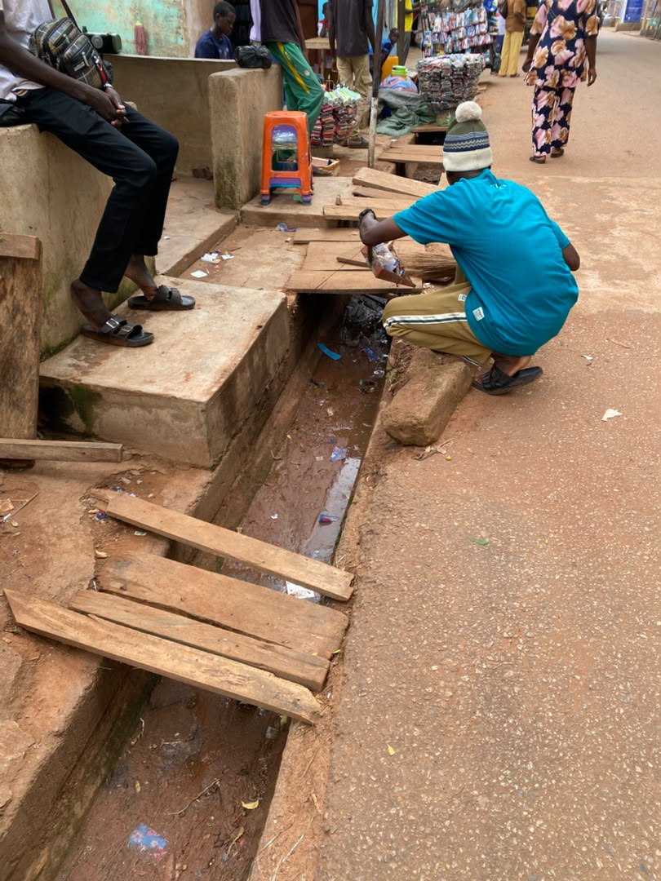
Figure 1: Community members desilting a public gutter at Walewale along market road.

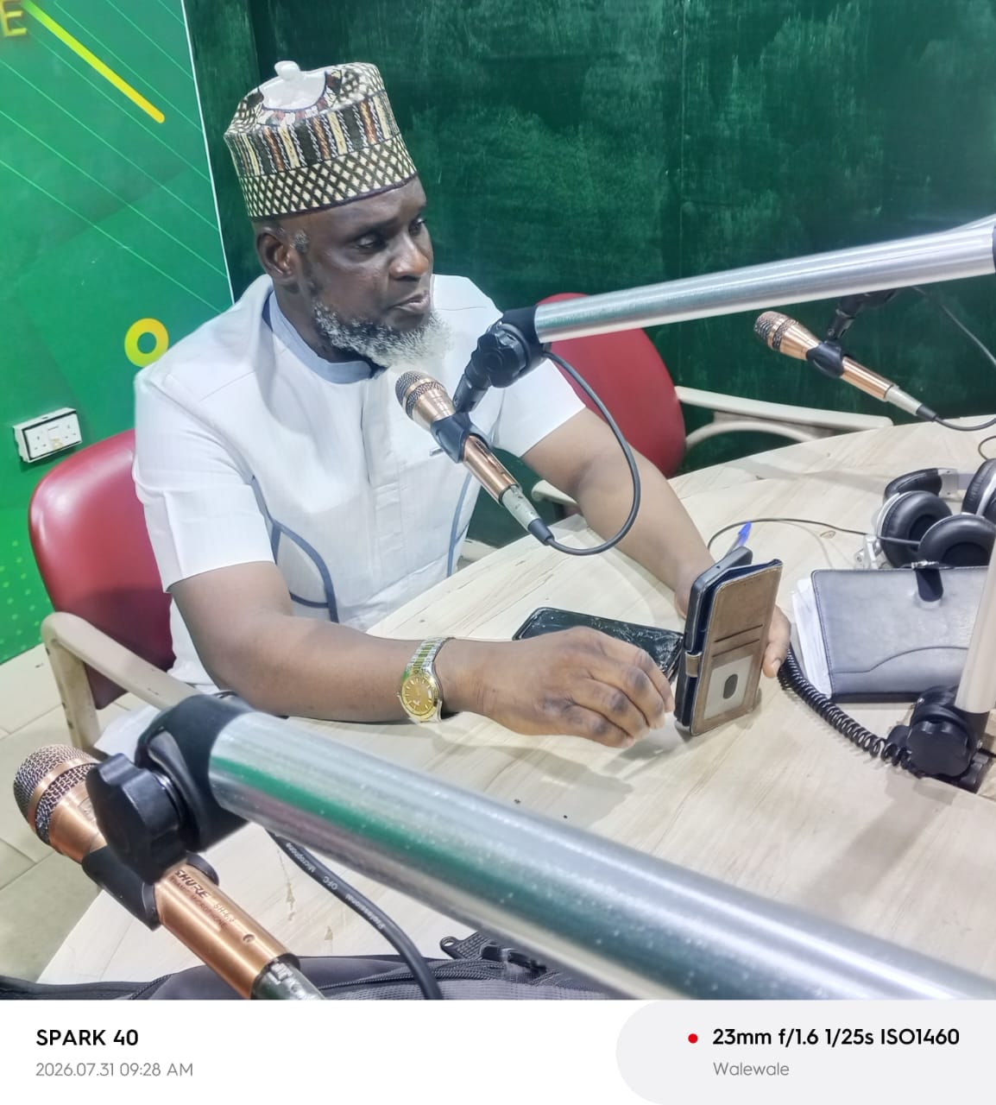
Figure 2: Honorable MCE on air sensitizing the public about NSD at Eagle FM, Walewale


Figure 3: Environmental health officer with assembly members sensitizing the public on air.

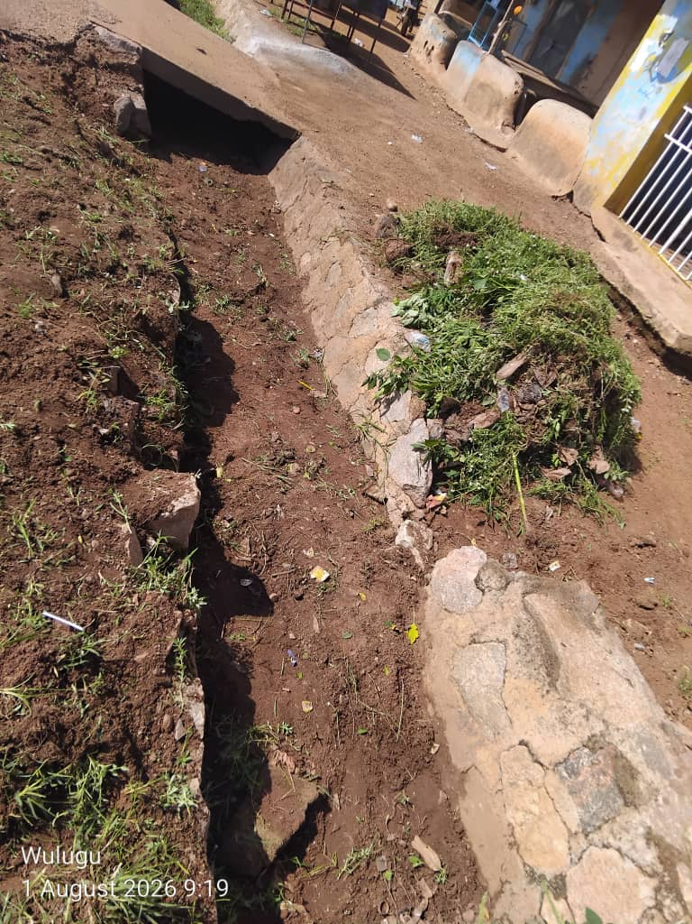
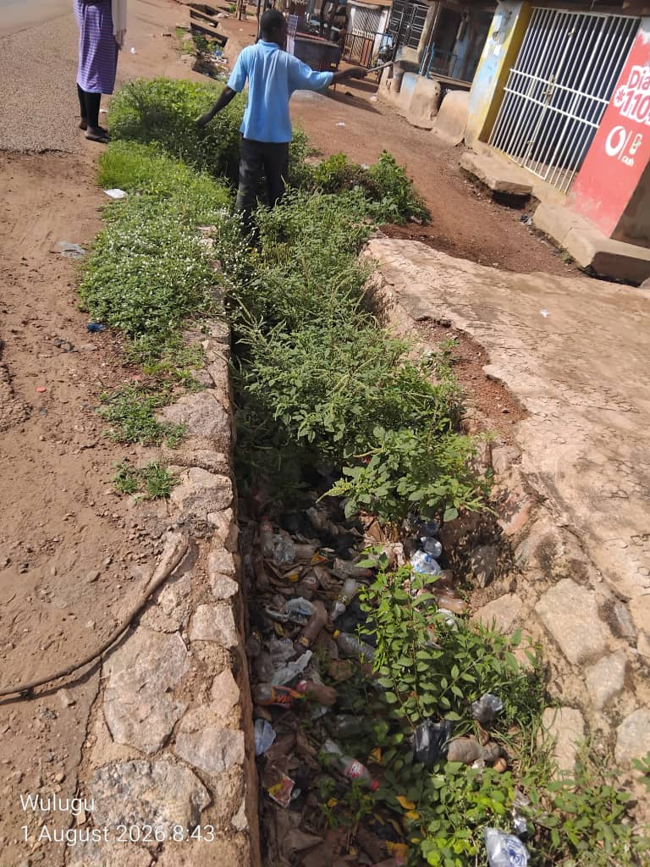
Figure 4: Before and after cleaning a gutter at Wulugu

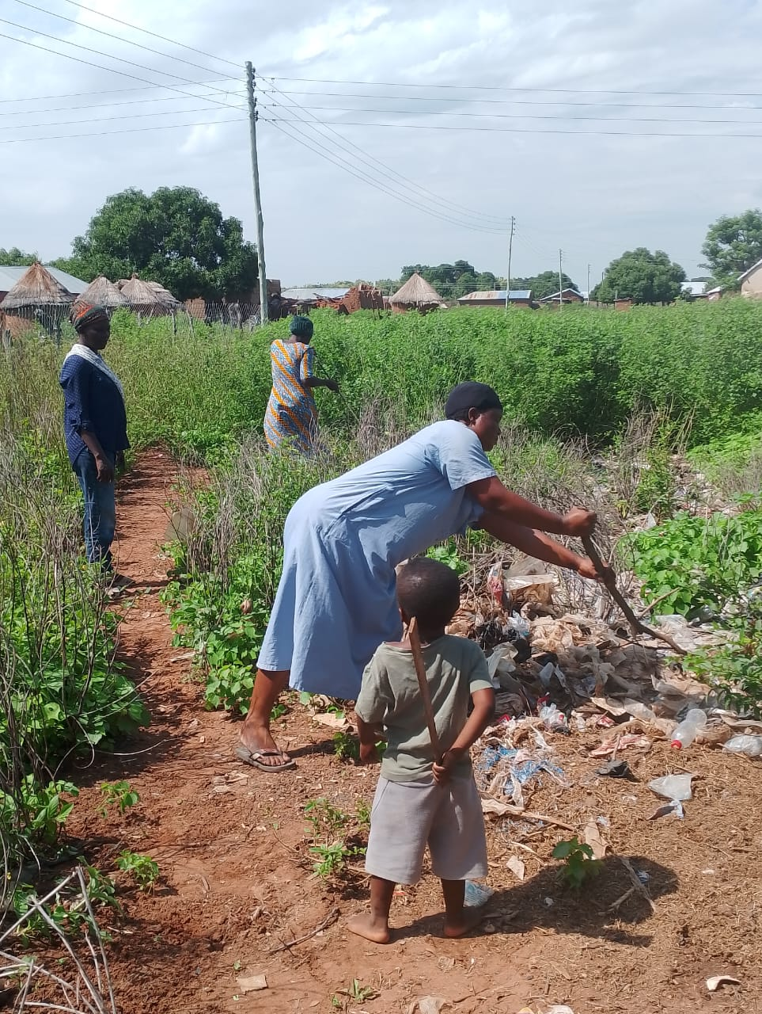
Figure 5: A householder taking part in the exercise at Tinguri

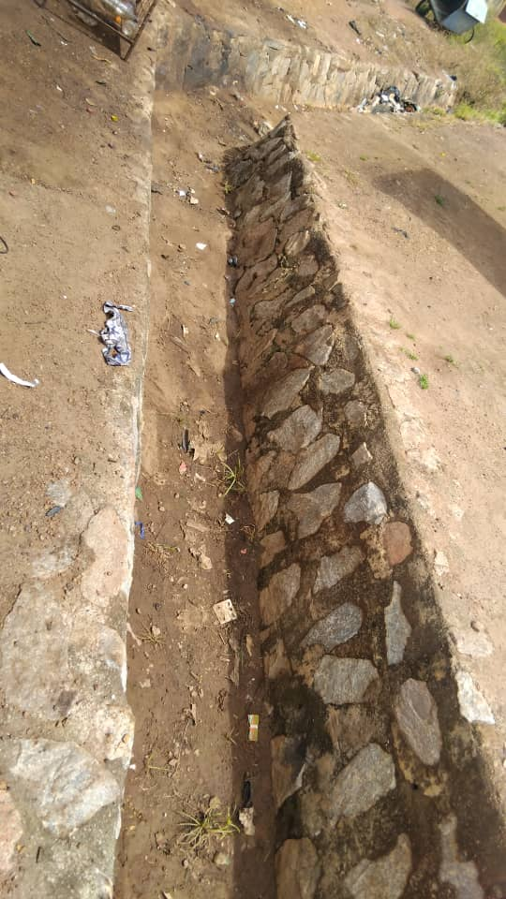
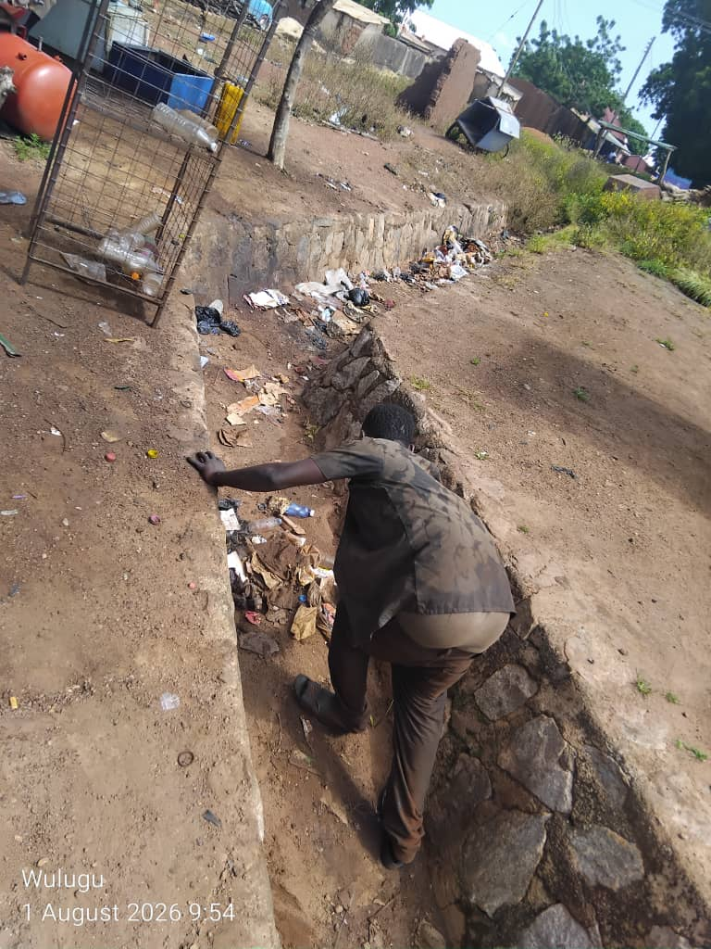
Figure 6: A before and after community member cleaning public gutter at Wulugu.

